**KAJJANSI HIGH SCHOOL**

**SET 2 ASSESSMENT TERM ONE 2024**

**S.3 PHYSICS**

**TIME: 2 hours**

**NAME**: ----------------------------------------------------------------------------------------------------------

**INSTRUCTIONS**

This paper consists of two sections; section A and section B. Attempt all questions in both sections.

**SECTION A**

1(a) The acceleration due to gravity on the Moon is 1.6Nkg-1 . An astronaut has a mass of 75kg. What is the weight of the astronaut on the Moon? (02 marks)

…………………………………………………………………………………………………………………………………………………………………………………………………………………………………………………………………………………………………………………………………....…………………………………………………………………………………………………………………………………………………………………………………………………………………………………………………………………………………………………………………………………...

(b) In a tag of war competition, VALENTINE applied a force of 80N on the rope while MATHEW applied a force of 50N on the same rope at the same time. (02 marks)

MATHEW

VALENTINE



Who of the two students won the competition? Explain your answer. (02 marks)

…………………………………………………………………………………………………………………………………………………………………………………………………………………………………………………………………………………………………………………………………....…………………………………………………………………………………………………………………………………………………………………

(2) Mr. Masaba is a farmer in a certain village, he harvested beans after growing them in a season and collected them in a store. He wanted to sell the beans but did not know the amount of beans he had in the store. So, he asked his son Luswata in Senior two to help him measure the beams

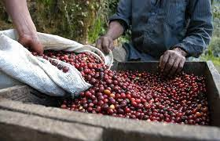

1. In which Quantity was Luswata supposed to measure the beans. (01 mark)

………………………………………………………………………………………………………………………………………………………

1. Name the S I unit of the quantity named in (a) above. (01 mark

………………………………………………………………………………………………………………………………………………………

(c) Which instrument is most suitable for measuring the beans? (01 mark)

………………………………………………………………………………………………………………………………………………………

3(a) Define the term pressure (01mark)

………………………………………………………………………………………………………………………………………………………

………………………………………………………………………………………………………………………………………………………

(b)Explain the following

1. a dam is made thickest at the bottom than at the bottom

………………………………………………………………………………………………………………………………………………………………………………………………………………………………………………………………………………………………………………

………………………………………………………………………………………………………………………………………………………

1. A pin penetrates deeper than a nail if someone steps on them.

………………………………………………………………………………………………………………………………………………………………………………………………………………………………………………………………………………………………………………

………………………………………………………………………………………………………………………………………………………

4(a) A hydraulic jerk is used to lift the car by applying a force of 120N at the pump. If the area of the ram and pump piston are 100cm2 and 1m2. Calculate the force that is applied on the ram piston

…………………………………………………………………………………………………………………………………………………………………………………………………………………………………………………………………………………………………………………..

………………………………………………………………………………………………………………………………………………………………………………………………………………………………………………………………………………………………………………………………………………………………………………………………………………………………………………………………………………

4(b) Explain why a liquid is used in hydraulic machines and not gases.

………………………………………………………………………………………………………………………………………………………………………………………………………………………………………………………………………………………………………(01marks)

5(a) In your community some of the roads are murram. During the rainy season lorries and lorry trucks usually skid, slide or get stuck in the mud. If you found a driver stuck in the mud (soft and slippery situation)

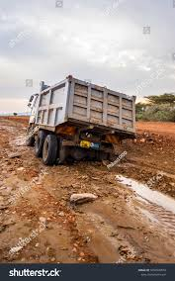

1. Suggest possible ways to remove the truck from this position.

………………………………………………………………………………………………………………………………………………………………………………………………………………………………………………………………………………………02marks

1. Advise the driver on how to avoid the above situation

……………………………………………………………………………………………………………………………………………………………………………………………………………………………………………………………………………………………02marks

6(a) Distinguish between potential energy and kinetic energy. ( 04marks )

………………………………………………………………………………………………………………………………………………………………………………………………………………………………………………………………………………………………………………

………………………………………………………………………………………………………………………………………………………

A ball of mass 100g falls freely a tower of a height 192m. calculate the kinetic energy of the ball as it hits the ground.

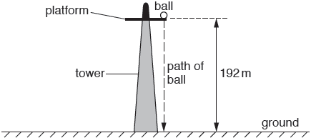

7(a) Distinguish between basic and derived quantity. (02 marks)

……………………………………………………………………………………………………………………………… ………………………………………………………………………………………………………………………………

(b) State any two examples of each above quantities (02 marks) ……………………………………………………………………………………………………………………………… ………………………………………………………………………………………………………………………………

8(a)Define the efficiency as used in machines.

……………………………………………………………………………………………………………………………………………………………………………………………………………………………………………………………………………………………………………………………………((b) A worker wants to load a drum of weight 1000N on a truck whose floor is 1m above the ground. The man rolls the drum up a plank 3m long with a force of 400N.

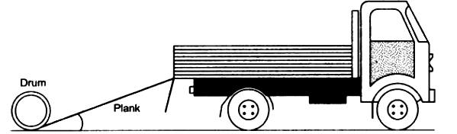

calculate the;

1. the work output ………………………………………………………………………………………………………………………………………………………………………………………………………………………………………………………………………………………………………………………………………………………………………………………………………………………
2. the work input ………………………………………………………………………………………………………………………………………………………………………………………………………………………………………………………………………………………………………………………………………………………………………………………………………(03marks)

9(a) State kinetic theory of matter. (02marks)

…………………………………………………………………………………………………………………………………………………………………………………………………………………………………………………………………………………………………………………………………………………………………………………………………………………………………………………………………………………………………………………………………………………………………………………………………………………………………………………………………………

(b)Explain why it is easier to compress a gas than a solid (02marks)

……………………………………………………………………………………………………………………………………………………………………………………………………………………………………………………………………………………………………………………………………

10. 50cm3 of paraffin of density 800kg/m3 was added to 150cm3 of water of density 1g/cm3. Find the density of the mixture. (04marks)

……………………………………………………………………………………………………………………………………………………………………………………………………………………………………………………………………………………………………………………………………

……………………………………………………………………………………………………………………………………………………………………………………………………………………………………………………………………………………………………………………………………

……………………………………………………………………………………………………………………………………………………………………………………………………………………………………………………………………………………………………………………………………

**SECTION B**

11. Your grandfather has got a piece which he wants to sell to an investor intending to set up a factory. This old man does not understand any other units of measurement except using a stick which is 12 feet long. The investor on the other hand wants to pay for the land in hectare units, and It is very fortunate that it is a holiday and you are the right person to mitigate this conflict. Assuming the land measures 100 sticks in length and 50 sticks in width, and that 1𝑓𝑜𝑜𝑡 = 30𝑐𝑚 and 1 ℎ𝑒𝑐𝑡𝑎𝑟𝑒 = 10,000𝑚2 help your grandfather to evaluate the total cost of the piece of land if one hectare costs 10millions. (10 marks

**END**